===================

Helm architecture

===================

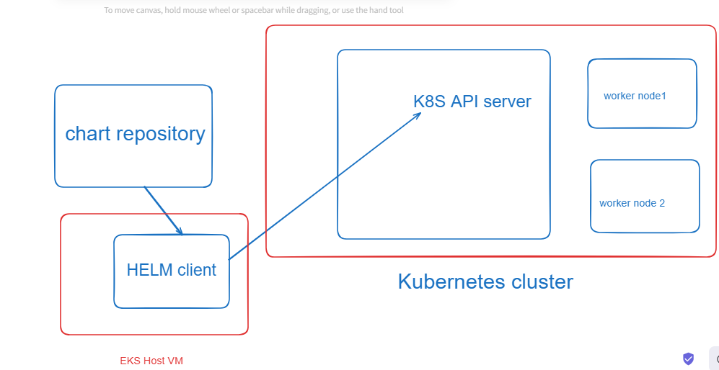

=============

Prometheus

=============

-> Prometheus is an open-source systems monitoring and alerting toolkit

-> Prometheus collects and stores its metrics as time series data

-> It provides out-of-the-box monitoring capabilities for the k8s container orchestration platform.

========

Grafana

========

Grafana is a monitoring tool and Grafana is multiplatform opensource analytics and interactive visualization web application

it provides charts, graphs and alerts for the web

Grafana also allows you to query, visualize alert on and understand your metrics no matter when they are stored

Grafana will connect with Prometheus for data source

==========

EFK stack

==========

It is the combination of 3 opensource products

E - Elastic search - for storing logs

F - fluentd - for shipping, processing and storing logs

K - Kibana - Visualization tool to monitor the logs

==============

EFK Stack setup

===============

EFK stack is a collection of three opensource products

E- Elastic search (For storage logs -log lake)

F- fluentd - for shipping, processing, and storing logs

K- Kibana - visualization tool to monitor the logs

EFK stack provides centralized logging to identify problems with servers and applications

It allows you to search all the logs in single place

When we running the application in the production environment multiple users will be accessing the application and there may be a chance of getting an exception also in our application, for that we need to monitor the logs of the application. Log monitoring is the one of the important tasks in the real time environment. Application will be deployed in multiple containers/pods/servers monitoring the logs of all the pods will be a difficult task. To avoid problem, we need to segregate the logs of our application and we should provide a single platform to set all the logs of the application. that why we used efk stack

To view log of single pod

# kubectl logs <pod name>

Application will be running in multiple containers and those application containers are going to generate the logs, when logs are generated and those logs should be collected by the fluentd, fluentd sent the logs to elastic search, Elastic search should give the logs to kibana. We will use kibana dashboard to get the logs of the application.